This problem will be worth 15 points. Each successfully implemented function will earn you a point. There is the one student tester and one test for each of the 10 functions for a total of 11 tests. Additional bonus points will be awarded for correctly implementing methods 1-4, methods 5 and 6, methods 7-10 and a final bonus point for correctly implementing all 10 methods in this class.

This problem will ask you to implement the following functions. One function is defined recursively. Other times I will give you functions from the java.lang.Math with a brief description, and some times you just need to implement the function. In all the following functions you do NOT need worry about domain issues. That is, you may assume that all test data will not cause any exceptions to be thrown. In total, there are ten different functions in this problem. Except for the first method and all Boolean methods, all methods return a double. Your method must return value within 0.05 of the correct answer to be considered correct.

You should use:
- Math.abs(x) for |x|. | - Math.cos(a) for cos(a)
- Math.sqrt(x) for 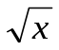 | - Math.sin(a) for sin(a)
- Math.pow(x, 1.0/n) for 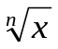 | - Math.tan(a) for tan(a)
- Math.log(a) for 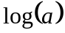 | - Math.ceil(a) for 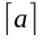.
- Math.log10(a) for 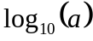 | - Math.floor(a) for 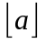.
note:
- Return type of Math.abs(x) is the same as the argument x.
- Return type of all other methods is double.
- 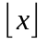 is the largest (Closes to positive infinity) double value smaller than or equal to x. For example, 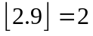 and 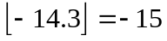.
- 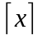 is the smallest (Closes to negative infinity) double value that is greater than or equal to x. For example, 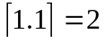 and 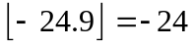.

- Implement the following recursive function.
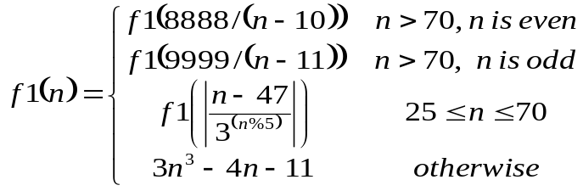
using the following function heading:
public static int f1(int n)

Test data: f1(11) returns 3938

The correct call to a recursive static method is of the form: FunctionsGoneWild2012.f1(n)
- Implement the following function.
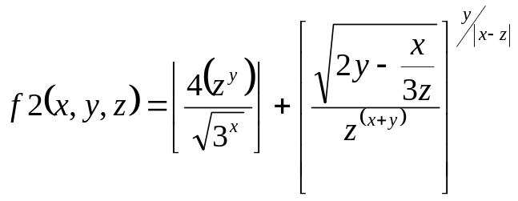
Use the following function heading:
public static double f2(double x, double y, double z)

Test data: f2(2, 3, 5) returns 166.000775

The correct call to the static method is of the form: FunctionsGoneWild2012.f2(x, y, z)

3. Implement the following function
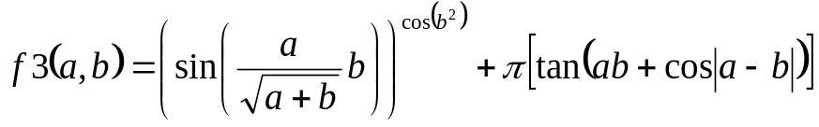,
Use the following constant for pi (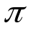)
Math.PI | The double value that is closer than any other to pi, the ratio of the circumference of a circle to its diameter.

Use following function heading:
public static double f3(double a, double b)

Test data: f3(3.5, 1.5) returns -24.500

The correct call to the static method is of the form: FunctionsGoneWild2012.f3(a, b)
4. Implement the following function
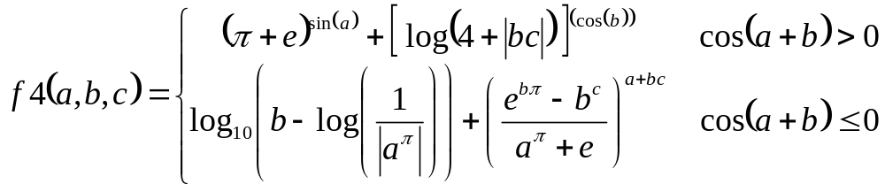
Use the following constant for both pi () and 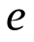
Math.PI | The double value that is closer than any other to pi, the ratio of the circumference of a circle to its diameter.
Math.E | The double value that is closer than any other to e, the base of the natural logarithms.
Use following function heading:
public static double f4(double a, double b, double c)

Test data: f4(-5, 0, 11) returns 6.83567

The correct call to the static method is of the form: FunctionsGoneWild2012.f4(a, b, c)

- Implement the following function.
Consider the mathematical notation 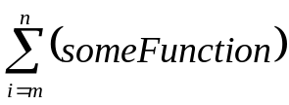 used to represent the summation of many similar terms. The notation 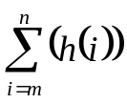 is defined as:
The subscript gives the symbol for an index variable, i. Here, i represents the index of summation; m is the lower bound of summation, and n is the upper bound of summation. In this case, i = m under the summation symbol means that the index i starts out equal to m. Successive values of i are found by adding 1 to the previous value of i, stopping when i = n. An example: 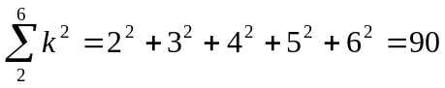.

Your task in this problem is to implement the following function.
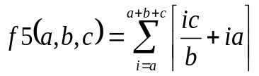 = 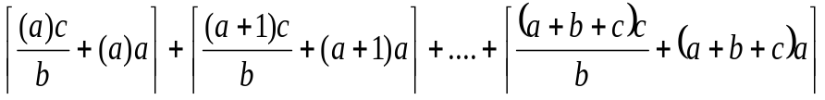
using the following function heading:
Special note – all calculations are to be competed using integer math
public static int f5(int a, int b, int c)

Test data: f5(5, 13, 7) returns 1734
6. Implement the following function
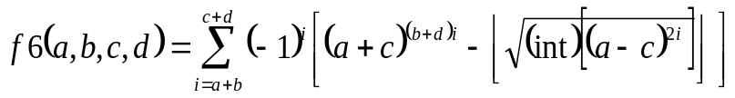 =
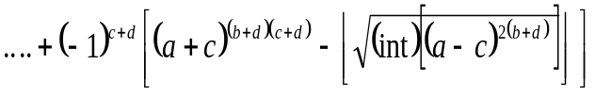
Special note – all calculations are double math, then cast to int for the sum

Use following function heading:
public static double f6(int a, int b, int c, int d)

Test data: f16(1, 1, 2, 2) returns 512486

- Implement the following function
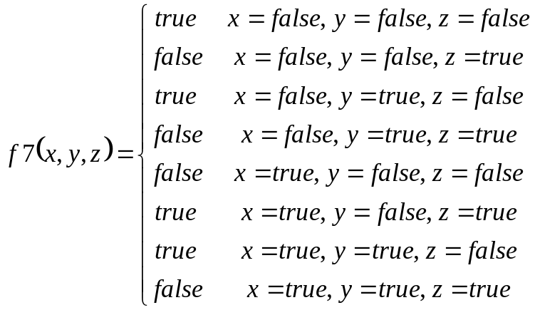
Use following function heading:
public static boolean f7(boolean x, boolean y, boolean z)

Test data: f7(false, true, false) returns true

- Implement the following function
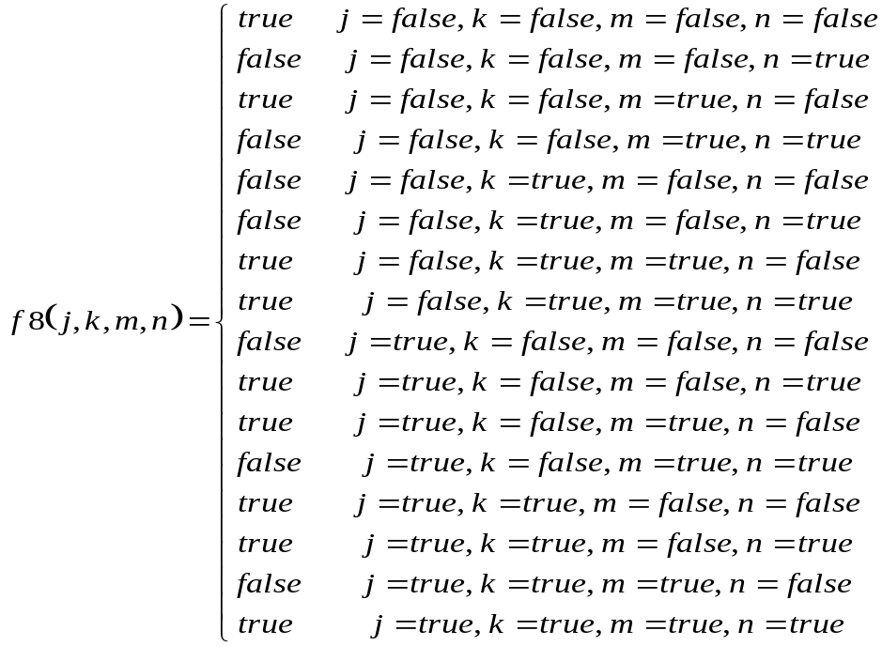
Use following function heading:
public static boolean f8(boolean j, boolean k, boolean m, boolean n)

Test data: f8(false, false, false, false) returns true

- Implement the following function
JUST RETURN Math.PI

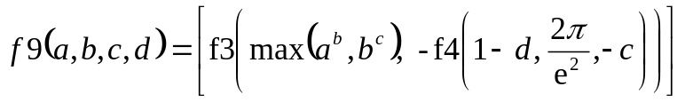
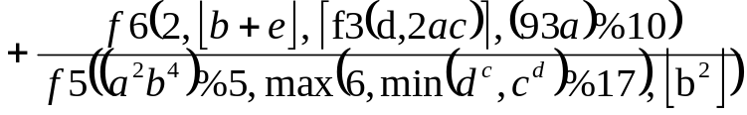
Use following function heading:

Recall Math.PI and Math.E are constant that should be used as for the values π and e.

public static double f9(double a, double b,
double x, double y, double z)

Test data: f9(6, 7, 5, 2) returns Math.PI; -19.6234472

- Implement the following function
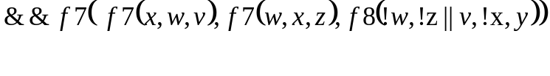
Use following function heading:
public static boolean f10(boolean v, boolean w, boolean x,
boolean y, boolean z)

Test data: f10(false, false, false, false, false) returns true

Each of the above functions is tested individually. Each function that is correctly implemented will earn one point. Additional bonus point for correctly implementing all groups of functions correctly as described in the first paragraph will be awarded! A total of 15 points are available.

